**NAME: HAMZA SAIF**

**CMS ID: 481070**

**ME-15(C)**

**TASK#1:**

Write a C++ program to calculate average of numbers of array

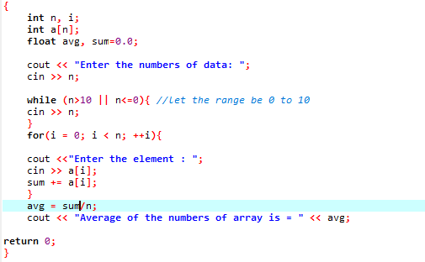

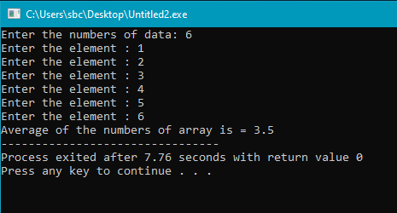

**TASK#2:**

Implement Bubble sort on an array of 5 integers.

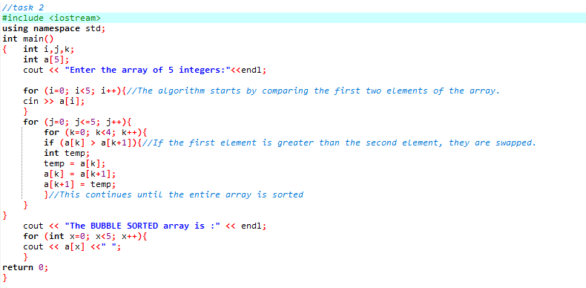

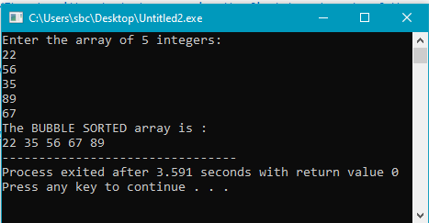

**Task#3:**

Implement Selection Sort on an array of 5 integers.

